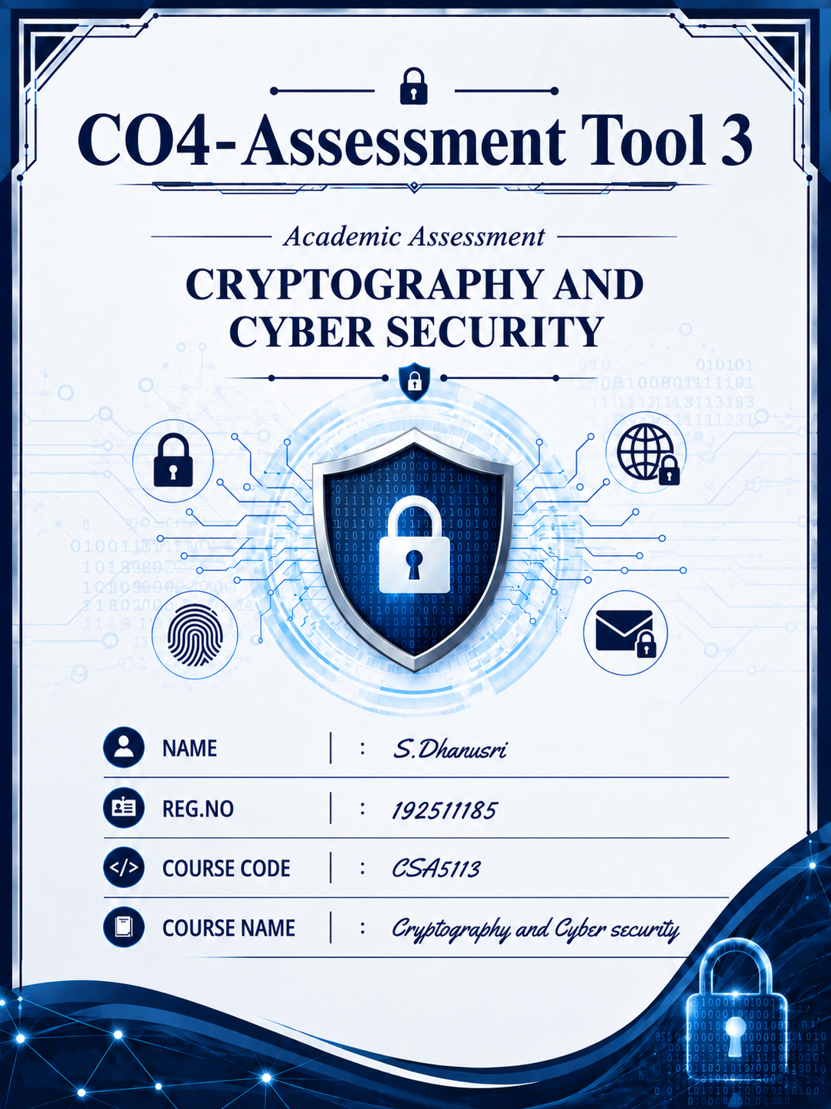1. Compare Authentication Header (AH) and Encapsulating Security Payload (ESP) in IPSec
The question asks for comparison based on security services, performance overhead, network scenarios, and VPN suitability.
Feature | AH | ESP
Authentication | Provides authentication | Provides authentication when integrity/authentication is enabled
Integrity | Provides data integrity | Provides data integrity
Confidentiality | Not provided | Provided through encryption
Anti-replay protection | Supported | Supported
Encryption | No | Yes
Overhead | Lower because there is no encryption | Higher because encryption and authentication require additional processing
NAT compatibility | Poorer | Better and commonly used with NAT traversal
Main use | Authentication and integrity | Confidentiality, integrity, authentication and anti-replay
AH
Authentication Header provides data integrity, data-origin authentication, and protection against replay attacks. It does not encrypt the actual data. Therefore, the contents of the communication remain visible.
AH is useful when the main requirement is to ensure that packets have not been modified and that they originated from an authenticated source.
ESP
Encapsulating Security Payload provides confidentiality through encryption and can also provide integrity, authentication, and anti-replay protection. Because of these additional services, ESP generally has more processing overhead than AH.
Performance
AH normally has lower computational overhead because it does not encrypt the payload. ESP requires encryption and possibly authentication, so it requires more processing. However, modern hardware acceleration makes ESP encryption highly efficient.
Suitability for network scenarios
- AH: Suitable when confidentiality is not required and integrity/authentication are the primary requirements.
- ESP: Suitable for secure communication over untrusted networks, remote access, site-to-site VPNs, and applications where confidentiality is required.
Recommendation for VPN
ESP is more appropriate for VPN deployment. A VPN normally needs to protect confidential information from being viewed by attackers. ESP provides encryption along with integrity and authentication capabilities, making it more suitable than AH for modern VPN implementations.
Conclusion: AH is useful for authentication and integrity, whereas ESP provides a more complete security solution. Therefore, ESP should generally be preferred for VPNs.

2. Compare Transport Mode and Tunnel Mode in IPSec
The question asks you to compare both modes and evaluate them for host-to-host and network-to-network communication.
Feature | Transport Mode | Tunnel Mode
IP header | Original IP header remains | Original IP packet is encapsulated
Protection | Mainly protects the payload | Protects the entire original IP packet
New IP header | No new outer IP header | New outer IP header is added
Main use | Host-to-host communication | Network-to-network and VPN communication
Overhead | Lower | Higher
Security | Good for direct host communication | Stronger protection of internal network information

Transport Mode
In transport mode, the original IP header is retained while the upper-layer payload is protected. Therefore, the communicating endpoints are directly involved in IPSec processing.
It is appropriate for host-to-host communication, such as secure communication between two servers or two individual computers.
Tunnel Mode
In tunnel mode, the complete original IP packet, including its original IP header, is encapsulated and protected. A new IP header is added for routing.
Tunnel mode is particularly suitable for network-to-network communication, where IPSec gateways protect traffic between two networks.
Host-to-host effectiveness
For host-to-host communication, transport mode is generally more efficient because it has less overhead and directly protects the communication between the two hosts.
Network-to-network effectiveness
For network-to-network communication, tunnel mode is more effective because it protects the entire original packet and allows security gateways to establish a secure connection between networks.
Example
A company has two offices:
Office A → Internet → Office B
A VPN gateway at each office can use IPSec tunnel mode to securely connect the two internal networks.
For:
Computer A → Computer B
within a direct host-to-host security arrangement, transport mode can be used.
Conclusion
Transport mode is best suited for host-to-host communication, while tunnel mode is preferred for network-to-network VPN communication. Tunnel mode provides greater protection of the original IP packet but introduces additional overhead.

3. Compare PGP and S/MIME for Enterprise Email
The question specifically requires comparison based on key management, trust models, scalability, enterprise usability, followed by a recommendation.
Feature | PGP | S/MIME
Key management | Users commonly manage their own keys | Uses certificates issued by CAs
Trust model | Web of Trust | Hierarchical PKI
Centralized management | More difficult | Easier
Scalability | Can become complex in large organizations | Highly suitable for large organizations
Enterprise integration | Requires additional management | Good integration with enterprise email systems
Authentication | Public-key based | Certificate-based
Deployment | More user-oriented | More organization-oriented
Best suited for | Individual users and decentralized environments | Corporate and enterprise environments
PGP
Pretty Good Privacy uses public-key cryptography for email encryption and digital signatures. Its traditional trust model is based on a Web of Trust, where users can sign and validate each other's public keys.
This gives users greater control but can make key management complicated as the number of users increases.
S/MIME
S/MIME uses digital certificates to authenticate public keys. Certificates are generally issued and managed through a Certificate Authority (CA) within a Public Key Infrastructure (PKI).
This provides a more centralized trust model and makes it easier for organizations to manage users and certificates.
Key management
PGP requires users to manage and verify public keys. In a large organization, maintaining thousands of keys can become difficult.
S/MIME uses certificates, making centralized certificate issuance, renewal, revocation, and management easier.
Trust model
PGP traditionally uses a Web of Trust, where trust can be established between users.
S/MIME uses a hierarchical certificate-based trust model, where trusted Certificate Authorities validate certificates.
Scalability
PGP can be effective for smaller or decentralized groups but becomes more complicated when the number of users grows.
S/MIME is more scalable because organizations can centrally manage certificates through PKI.
Enterprise usability
S/MIME is generally easier to integrate into corporate email environments because organizations can centrally manage certificates and policies.
Recommendation
S/MIME is the more suitable choice for a corporate email system.
The main reasons are:
- Centralized certificate management.
- Easier administration.
- Better scalability.
- Integration with enterprise email infrastructure.
- Strong user authentication through digital certificates.
Conclusion: PGP is useful when decentralized control and user-managed trust are preferred, whereas S/MIME is generally better for large corporate email systems because of its centralized PKI-based trust and management.

4. Compare Rule-Based and Machine Learning-Based Email Spam Detection
The question requires comparison based on effectiveness against evolving spam patterns and minimizing false positives.
Feature | Rule-Based Detection | Machine Learning-Based Detection
Method | Uses predefined rules | Learns patterns from data
Adaptability | Low | High
New spam patterns | Requires new rules | Can learn new patterns
False positives | Can be high if rules are too strict | Can be reduced with proper training
Maintenance | Requires manual updates | Requires training and monitoring
Complexity | Simple | More complex
Large-scale detection | Limited adaptability | Highly suitable
Rule-Based Spam Detection
Rule-based systems identify spam using predefined conditions.
For example, a system may classify an email as spam if it contains certain suspicious words, links, sender information, or formatting patterns.
Advantages
- Simple to understand.
- Easy to implement.
- Easy to explain why an email was classified as spam.
- Does not require large training datasets.
Disadvantages
The major problem is that spam techniques continuously change. Attackers can modify words, domains, links, and message structures to bypass predefined rules.
Rules that are too strict can also incorrectly classify legitimate emails as spam, causing false positives.

Machine Learning-Based Detection
Machine learning systems learn characteristics of spam and legitimate emails from previously labelled data.
The model can identify patterns involving:
- Email content.
- Sender characteristics.
- URLs.
- Message structure.
- Frequency and behavioural patterns.
Advantages
Machine learning is more adaptable to changing spam patterns. When new training data becomes available, the model can be updated to recognize new types of spam.
It can also reduce false positives when properly trained because it considers multiple characteristics instead of relying on a single fixed rule.
Disadvantages
- Requires quality training data.
- Requires regular monitoring and retraining.
- More complex than rule-based systems.
- Poor training data can lead to incorrect classifications.
Handling evolving spam
Machine learning is more effective because it can learn changing patterns, whereas rule-based systems require administrators to manually create or modify rules.
Minimizing false positives
Machine learning can achieve better results when trained with representative examples of both spam and legitimate emails. However, it is not automatically perfect; inappropriate training can also produce false positives.
Conclusion
Machine learning-based spam detection is generally preferable for modern email systems because it adapts better to evolving spam techniques and can reduce false positives when properly trained. Rule-based detection can still be useful as an additional layer for known spam patterns.

5. Compare Manual and Automated Key Management in IPSec
The question asks you to compare both approaches based on security, scalability, and operational complexity in large organizations.
Feature | Manual Key Management | Automated Key Management using IKE
Key configuration | Manually configured | Automatically negotiated
Scalability | Poor | High
Administration | Time-consuming | Less manual work
Security | Greater risk of configuration mistakes | Automated negotiation and security parameters
Large organizations | Difficult to manage | Suitable
Key renewal | Manual | Automated
Operational complexity | High as network grows | Lower
Maintenance | Difficult | Easier

Manual Key Management
In manual key management, administrators configure cryptographic keys and security parameters manually on IPSec devices.
For a small network, this can be manageable. However, as the number of devices increases, the number of keys and configurations also increases.
Advantages
- Simple for small environments.
- Predictable configuration.
- Does not require an automated key-exchange infrastructure.
Disadvantages
- Time-consuming.
- Difficult to scale.
- Increased possibility of configuration errors.
- Key replacement and revocation become difficult.
- Poor choice for large organizations.

Automated Key Management using IKE
IKE, or Internet Key Exchange, automates the negotiation of security parameters and cryptographic keys for IPSec.
Instead of administrators manually configuring every session key, the devices can negotiate the required security information.
Security
Automated key management improves security by reducing manual configuration errors and supporting dynamic key establishment and replacement.
Scalability
IKE is much more scalable than manual key configuration. In a large organization with many offices, servers, VPN gateways, and remote users, automatically establishing security associations is significantly easier than manually configuring every connection.
Operational complexity
Manual key management becomes increasingly complicated as the network grows.
With IKE, much of the key negotiation process is automated, reducing administrative workload.
Large-organization comparison
For example, consider an organization with hundreds of VPN connections.
With manual key management, administrators would need to configure and maintain many keys and security parameters manually.
With IKE, the devices can negotiate the required parameters automatically, making deployment and maintenance significantly easier.
Recommendation
Automated key management using IKE is the better choice for large organizations.
It provides:
- Better scalability.
- Reduced administrative effort.
- Automated key negotiation.
- Easier key renewal.
- Reduced configuration errors.
- Better operational efficiency.
Conclusion: Manual key management may be acceptable for small networks, but IKE-based automated key management is strongly preferable for large IPSec deployments because it provides better scalability, security management, and lower operational complexity.

